Design Document for Sorting System Using Mechatronics Principles

Introduction

This document describes the design and implementation of a sorting system using mechatronics principles. The system is based on a conveyor belt mechanism that sorts objects on colour, using a combination of sensors and motors controlled by an STM32.

#### **Overall System Overview**

The sorting system consists of a conveyor belt powered by motors, with a colour sensor placed along the belt to detect the colour of items passing on it. The system will have a mechanism to divert items to different bins based on the detected colour and have a count of it. The overall architecture involves:

* **Conveyor Belt Movement**: Driven by DC motors that rotate the rollers, moving items along the belt.
* **Colour Detection**: Using a colour sensor to detect the colour of each item as it passes the sensor.
* **Sorting Mechanism**: Servomotors control the diverting mechanism that moves items to the correct bin based on colour.
* **Control System**: STM32 that reads inputs from the sensor and controls the motors to ensure proper sorting.
* **Counting system**: 16x2 LCD display to have a count of the number of coloured objects.

#### **Components Selection**

#### **STM32 DEVKIT**

* **Model**: Arduino Uno
* **Reason for Selection**: The Arduino Uno is a widely used microcontroller that is easy to program and supports multiple I/O pins necessary for controlling the motors and sensors.

#### **DC Motors**

* **Model**: 12V DC Motor
* **Reason for Selection**: These motors provide sufficient torque to move the conveyor belt and are compatible with the L298N motor driver.

#### **Servo Motors**

* **Model**: SG90 Micro Servo Motor
* **Reason for Selection**: These servo motors are small, precise, and ideal for controlling the diverting mechanism to sort the items based on colour.

#### **Motor Controller (L298N)**

* **Model**: L298N Dual H-Bridge Motor Driver
* **Reason for Selection**: The L298N allows for the control of the direction and speed of DC motors, which is essential for running the conveyor belt.

#### **Colour Sensor**

* **Model**: TCS3200 Colour Sensor
* **Reason for Selection**: The TCS3200 is an affordable and reliable colour sensor that can detect a wide range of colours with good accuracy.

#### **Power Supply**

* **Model**: 12V Battery or Adapter
* **Reason for Selection**: Provides the necessary power for the motors and Arduino board, ensuring consistent performance.

#### **Conveyor Belt Components**

* **Materials**: Cardboard, rollers, and paper
* **Reason for Selection**: Cardboard is lightweight and easy to work with, and rollers help in reducing friction, allowing smooth movement of items along the belt.

Counting and Display Update:

* The updated counts are displayed on the LCD.

Circuit Diagram:

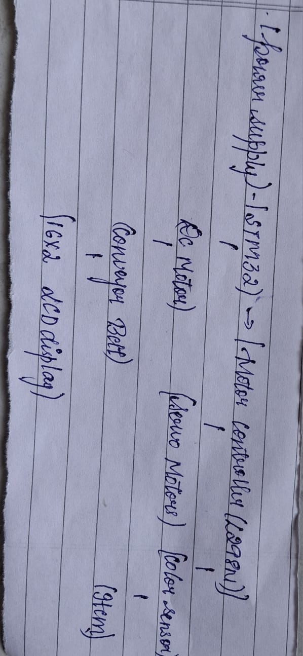

Code:

